TWO WAY COMMUNICATION
- Create Angular App
- ng new angular-app
- Create Angular Component
- ng g c child

PARENT CHILD communication using input
goto>app.component.html

<div class="container">
<h1>Two Way Communication</h1>
<h3>Parent Sending Data to Child</h3>
<input type="text" (keyup)="0" #pdata>
</div>

<app-child [pdata]="pdata.value"></app-child>

Goto> child.component.ts file
import { Component } from '@angular/core';

@Component({
selector: 'app-child',
templateUrl: './child.component.html',
styleUrls: ['./child.component.css'],
inputs:['pdata']
})
export class ChildComponent {

pdata:string="";
}

Goto>child.component.html and use it

<div class="container">
<h2>This is Child Component</h2>
<h3>Value coming from Parent: <b>{{pdata}}</b></h3>
</div>

Install bootstrap
- npm install bootstrap
import in style.css file
/* You can add global styles to this file, and also import other style files */
@import '../node_modules/bootstrap/dist/css/bootstrap.min.css'

Start the application
- ng serve
- localhost:4200
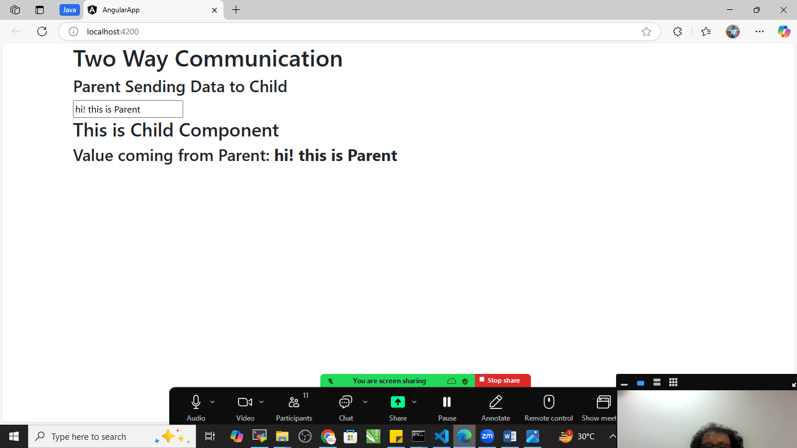

CHILD PARENT communication using EVENT EMMITER
Child.component.html

<div class="container">
<h2>This is Child Component</h2>
<h3>Value coming from Parent: <b>{{pdata}}</b></h3>
</div>

<div class="container">
<h3>Sending Data From Child to Parent</h3>
<input type="text" #cdata (keyup)="onChange(cdata.value)" />
</div>

Goto> child.component.ts file
import { Component, EventEmitter } from '@angular/core';

@Component({
selector: 'app-child',
templateUrl: './child.component.html',
styleUrls: ['./child.component.css'],
inputs:['pdata'],
outputs:['cevent']
})
export class ChildComponent {

pdata:string="";

cevent=new EventEmitter<String>();

onChange(value:string){
this.cevent.emit(value);
}
}

Goto> app.component.html file

<div class="container">
<h1>Two Way Communication</h1>
<h3>Parent Sending Data to Child</h3>
<input type="text" (keyup)="0" #pdata>
</div>
<div class="container">
<h3> Value coming from child:</h3><b>{{cdata}}</b>

</div>

<app-child (cevent)="cdata=$event" [pdata]="pdata.value"></app-child>
Goto> app.component.ts file
import { Component } from '@angular/core';

@Component({
selector: 'app-root',
templateUrl: './app.component.html',
styleUrls: ['./app.component.css']
})
export class AppComponent {
title = 'angular-app';
cdata:String="";
}

Save and check the out put
- use Bootstrap to Enhance the UI
